SKYKOMISH VALLEY FIRE AND RESCUE
P.O. Box 376
Gold Bar, WA. 98251
(360)793-1335

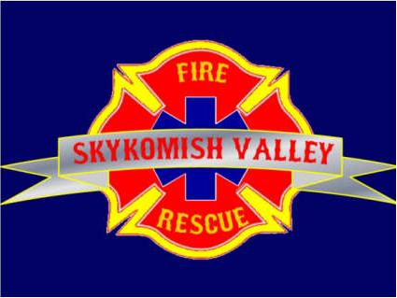

JOINT OPERATING BOARD
MEETING AGENDA
OCTOBER 2, 2025
STATION 54
ZOOM meeting ID: 873 9975 0952 Passcode: 544343

- Introductions (if needed)
- Minutes of May 7, 2025 Meeting
- Approval of minutes
- Chief’s Report
- ALS Statistical Report
- Old Business
- New Business
- Announcements (Other Business)
- Next Meeting May 13, 2026, 1900 hours, Station 53, Gold Bar, WA

